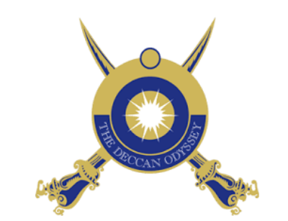

Deccan Odyssey – Discover Incredible India with us
(07Nights& 08 Days)

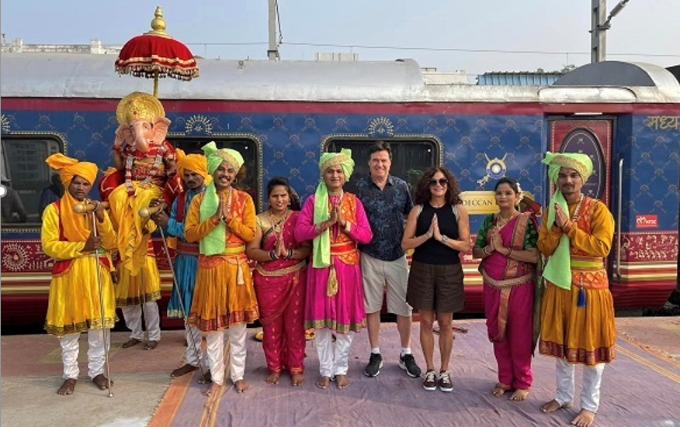
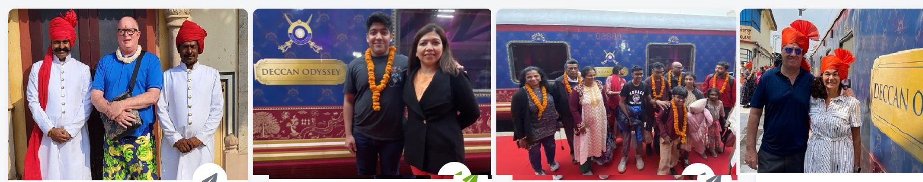

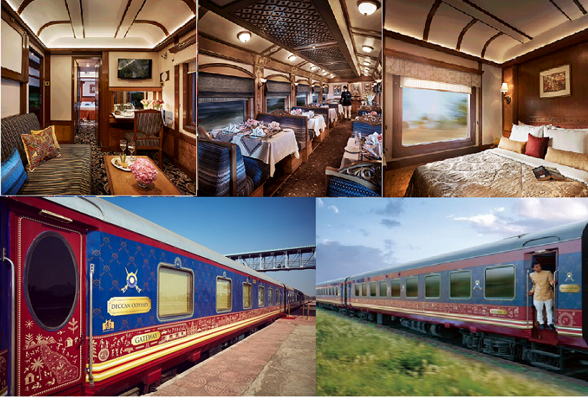

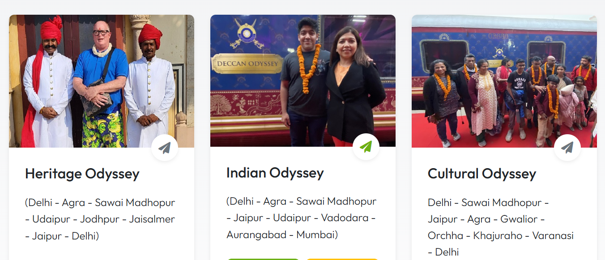

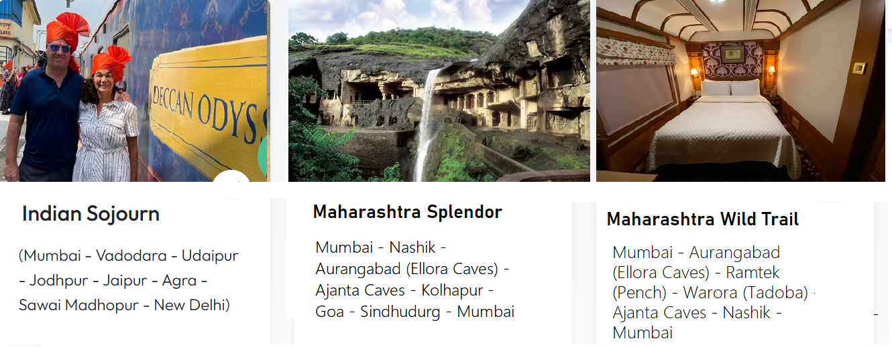

HERITAGE ODYSSEY - DECCAN ODYSSEY
(Delhi - Agra - Sawai Madhopur - Udaipur - Jodhpur - Jaisalmer - Jaipur - Delhi)

Visit India's architectural wonders and World Heritage Sites in Agra, Jaipur, Jodhpur, Jaisalmer and Ranthambore • Indulge in retail therapy visiting the colourful and bustling bazaars of the royal cities of Rajasthan • Experience the thrill of a safari in search of the elusive Tiger at Ranthambore.• Experience the thrill of a safari in search of the elusive Tiger at Ranthambore.• Enjoy Delhi to Jaisalmer in Luxury train via Sawai Madhopur, Agra, Jaipur and Jodhpur.
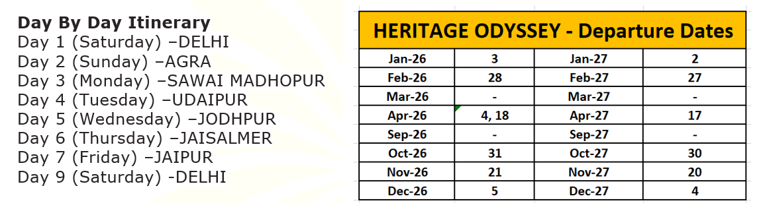

Deccan Odyssey - Special Offer - 2026-27
Cabin Type | Deluxe Cabin (TWIN) | Presidential Suite
Published Tariff | USD 13965 | USD 21000
01 Cabin - 02 Adults (Including All Taxes) - All Tours - Twin Sharing | Contact Us | Contact Us
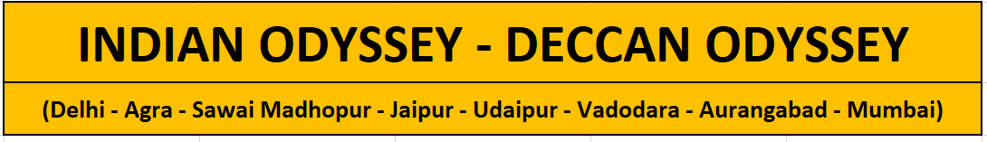
Experience an unforgettable Luxury Train Journeys of india with Deccan Odyssey Indian Odyssey Tour. This 7 Nights and 8 Days tour coversn north and west part of India, which includes National Parks, World Heritage Architectures, Palaces and much more.Its a carefully planned Itinerary made keeping in mind the taste of our guests. Luxury Odyssey India Tour Starts from Delhi and ends at Mumbai.
We welcome you on board the Deccan Odyssey.
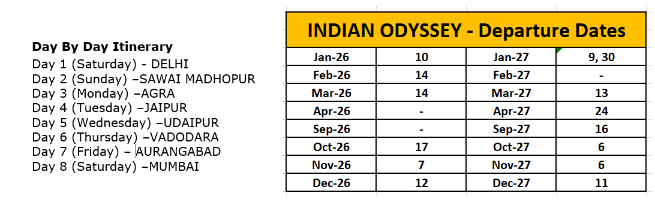

Deccan Odyssey - Special Offer - 2026-27
Cabin Type | Deluxe Cabin (TWIN) | Presidential Suite
Published Tariff | USD 13965 | USD 21000
01 Cabin - 02 Adults (Including All Taxes) - All Tours - Twin Sharing | Contact Us | Contact Us

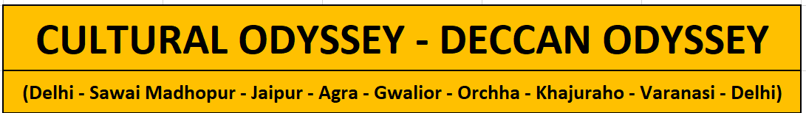
Experience an unforgettable Luxury Train Journeys of india - Cultural Odyssey Tour. This 7 Nights and 8 Days tour covers amazing cities like Agra, Gwalior, Jaipur, Varanasi, Khajuraho.Its a carefully planned Itinerary made keeping in mind the taste of our guests. Cultural Odyssey Tour Starts from Delhi and ends at Delhi. We welcome you on board the Deccan Odyssey.
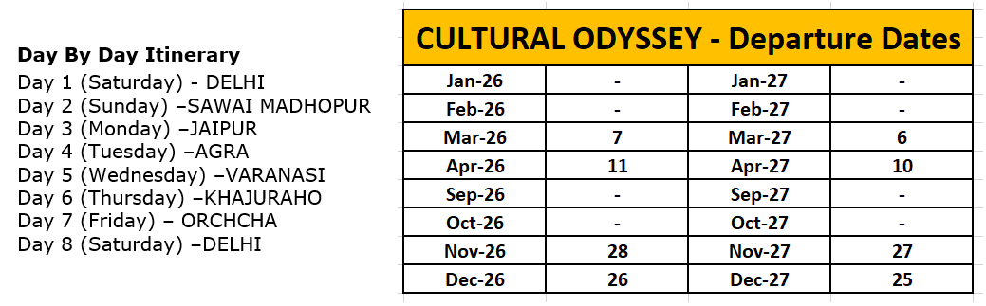

Deccan Odyssey - Special Offer - 2026-27
Cabin Type | Deluxe Cabin (TWIN) | Presidential Suite
Published Tariff | USD 13965 | USD 21000
01 Cabin - 02 Adults (Including All Taxes) - All Tours - Twin Sharing | Contact Us | Contact us

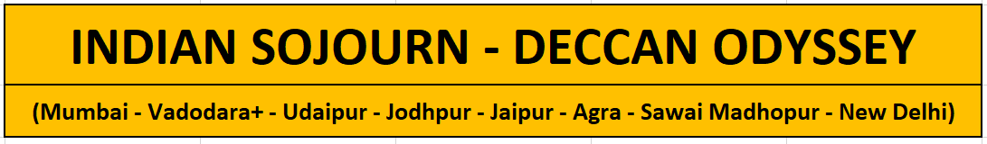
Experience an unforgettable Journey with Deccan Odyssey Indian Sojourn Tour. This 7 Nights and 8 Days Deccan Odyssey Train Route covers north and west part of India, which includes National Parks, World Heritage Architectures, Palaces and much more.Its a carefully planned Itinerary made keeping in mind the taste of our guests. The Deccan odyssey Indian Sojoun Tour Starts from Mumbai and ends at Delhi. We welcome you on board the Deccan Odyssey.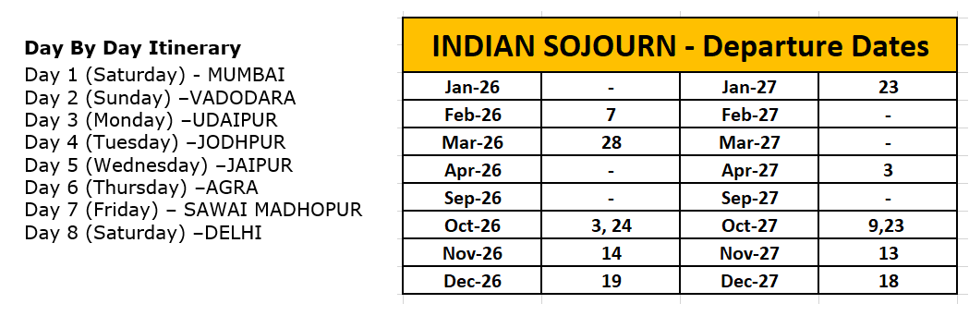
Deccan Odyssey - Special Offer - 2026-27
Cabin Type | Deluxe Cabin (TWIN) | Presidential Suite
Published Tariff | USD 13965 | USD 21000
01 Cabin - 02 Adults (Including All Taxes) - All Tours - Twin Sharing | Contact Us | Contact Us

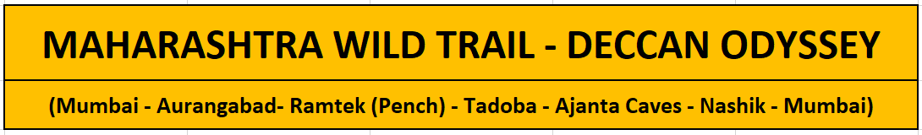
The wondrous and fascinating cave temples of Ajanta & Ellora along the western seaboard of India, both World Heritage sites, showcasing the ancient skill of India's painters and sculptors.Thrilling game drive in the wildlife parks of Tadoba Tiger Reserve where you get an opportunity to spot the Royal Bengal Tiger as well as various other species of birds and mammals.
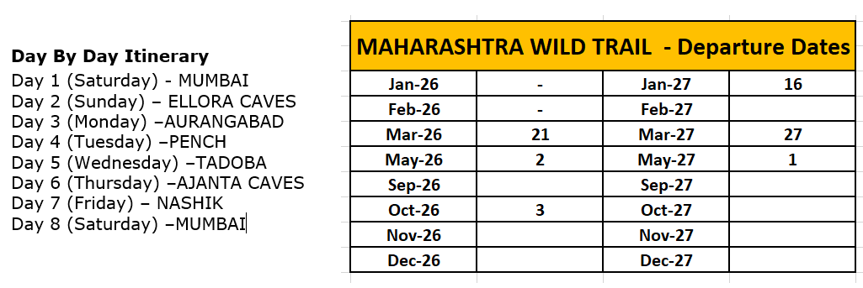
Deccan Odyssey - Special Offer - 2026-27
Cabin Type | Deluxe Cabin (TWIN) | Presidential Suite
Published Tariff | USD 13965 | USD 21000
01 Cabin - 02 Adults (Including All Taxes) - All Tours - Twin Sharing | Contact Us | Contact Us

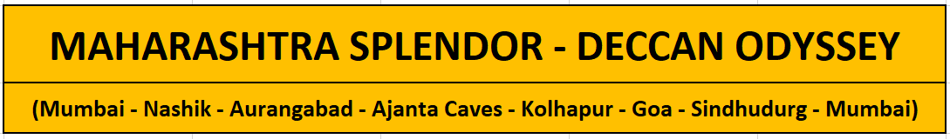

One of the most luxurious train of India - Deccan Odyssey brings you the best journey of Maharashtra.The Deccan odyssey Maharashtra Splendour Tour Starts from Mumbai and ends at Mumbai. We welcome you on board the Deccan Odyssey.

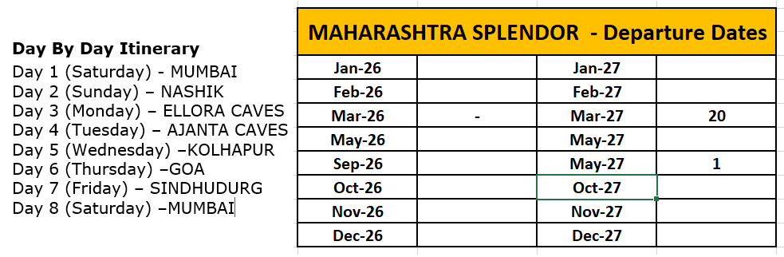

Deccan Odyssey - Special Offer - 2026-27
Cabin Type | Deluxe Cabin (TWIN) | Presidential Suite
Published Tariff | USD 13965 | USD 21000
01 Cabin - 02 Adults (Including All Taxes) - All Tours - Twin Sharing | Contact Us | Contact us

Deccan Odyssey – Tour Schedule

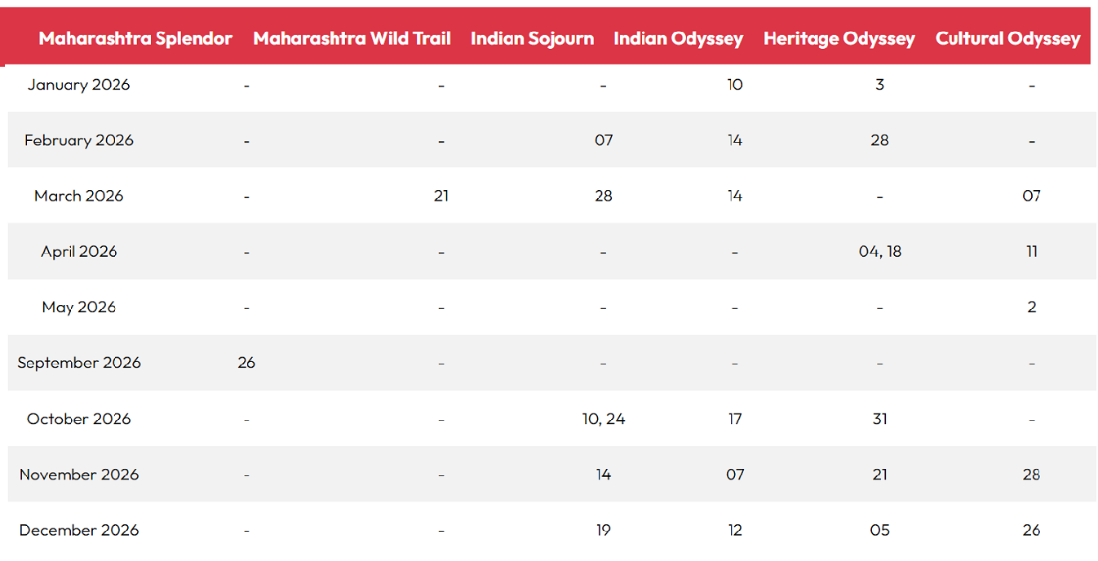
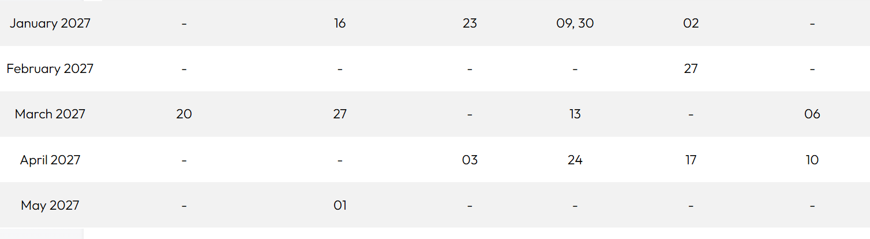

For More Custom Made & Private Tours, Please call/ Whatsapp - + 91 98106 81725
- Allpricesarein USDollars
- TheabovecostsarepercabinperJourney forIndian National/ForeignNational.
- As the train runs on the tracks of the Indian Railways, the itineraries are subject to change in case ofanychangesintherouting etc.
- Pricesaresubjecttochangeincaseofanyamendmentintheroutingorotherhikessuchasfuel,taxesetc.
- Childrenbelow5yearsofageshallbeallowedfree,subjecttosharingofdoublebedwithparents.Thisis subjectto availability ofdoublebedatthetimeof booking
- PresidentialSuitecanaccommodateupto3adultsor2Adultsand2children(Onechildupto5yearsofageandsecondchildupto12 years ofage)
- We need minimum occupancy to operate all listed tours, in event if we do not manage minimum occupancywe reservethe rightto cancel thejourneyatleast with45 dayspriorintimation

CHILDPOLICY
- Deccan Odyssey does accommodate children but we ask parents to be mindful of the sophisticatedadult atmosphereweendeavourtomaintain.
- One child up to 5 years of age shall be allowed free of cost in the Deluxe Cabin, subject to sharing ofdoublebedwithparents.This issubjecttoavailabilityofdoublebedatthetimeofbooking.
- Forfamily,01adult&01Childbetween05-12yearsage,sharing01deluxecabin,childwillbecharged50%ofadultfare.
- For families, with a child between 6-12 years of age, or, with two children with one child below 5yearsandanotherbetween
- 6-12years,werecommendthePresidentialSuitewhichhasadoublebedinthebedroomandcanbesharedwithachildbelow5yearsandasofacumbedinthelivingroomwhichcanaccommodatetheolderchild.Inthiscase,thechild/children willbeaccommodatedfreeof cost
- In case of two children between 6-12 years of age travelling with their parents, you will have to take2 cabins. The first child pays 25% of the adult fare and the second child will have to pay 50% of theadult fare.One oftheparentswillhavetobe presentwiththe child/ children inthecabin
- Pleasenotethatwedonothavethefacilityforinterconnectingcabins
- Allapplicabletaxeswillbe chargedextra

INCLUSIONS:
- Accommodationindouble/twinbeddedcabinwithensuitebathrooms
- All meals(B,L,D)
- Softbeveragesduringthejourney
- Valetservice
- Stillcamerafees
- Guidedofftrainexcursionsandgamedrivesasillustratedintheitinerary-inclusiveofentrancefees,parkfees,transportandservicesof anEnglishspeaking localguide

EXCLUSIONS:
- GST/VAT,Insurance,gratuities
- LaundryandalcoholicBeverages
- VideoandprofessionalStillcamerafees
- ArrivalandDeparturetransfers
- InternationalandDomesticairtickets/ Visafee
- PreandPosttouraccommodationandanytourextensionsunlessspecificallymentionedasapartofthejourney
- Allactivitiesmentionedas'options'intheitinerary

IMPORTANT NOTE:
✓If Due to Covid19 Travel Restrictions Or Low Occupancy Or Any other reason, the Scheduled Depart does not Operate or cancelled by the operator, You Will be Informed At least One Week Before Scheduled Depart, And Have option to adjust advance in Future Journey or a similar value credit note valid for 60 months, or request for a refund of the same.
Train Operators reserve the right to amend any tariff / fee / itinerary / cancellations/ refund rules or any rules etc., and any difference in tariff or additional charges is to be paid by the guest only as per the operators rules,
International / USD (United States Dollars) Refunds - all refund amounts would be calculated on the basis of actual INR (Indian Rupee) value received and any foreign exchange value difference is to be borne by you. LUXURY INDIA shall not be responsible for any such fluctuation in International currency and actual INR receipt shall be taken as base for all calculations. Luxury India reserves to deduct MINIMUM USD 235 per person towards Bank Charges / documentation charges in case of International refunds.

HOW TO CONFIRM THE TOUR OR CONFIRMATION PROCESS:

THE PROCESS OF TOUR CONFIRMATION & COMMUNICATION
Step 01:

-Selection & Finalization of the tour.
-Filling up booking form (which will be shared with you, along with cancellation & terms)
- Kindly share Passport copies, to refer the name/ nationality/ passport number

Step 02:

-Process the advance payment 30percent as per the invoice copy shared with you.
-If International flight ticket already arranged then share the details

Step 03:

After receiving the amount, you will receive the confirmation email & a letter from our end. Bifurcation of tour amount will also be shared (receiving and balance). Balance payment needs to be cleared atleast 95days prior to arrival.

Step 04:

If you still have any questions or would like to add anything, then kindly intimate us. We will check what are best possibility to bring the change (sometime thing will not fit in).

Step 05:

Clear balance payment 95days prior to arrival in India. After receiving balance payment, we will share the reciept email for the same.

Step 06:

On closer date or one week prior, we will share the arrival assistance details which say who will meet you at the airport & assigned guest relations manager.

CANCELLATION RULES –Deccan Odyssey :

- We are not the Deccan Odyssey Train Tour Operator & liability of Luxury India is limited to that of booking agent only.
- Cancellation requests must be made in writing & acknowledged by us.

Cancellation Charges :
- There will be MINIMUM levy of 10% cancellation fee on gross train ticket value -if informed more than 95 days before train tour depart.
- There will be MINIMUM levy of 30% cancellation fee on gross train ticket value -if informed between 60 days to 94 days prior to train tour depart.

- There will be MINIMUM levy of 50% cancellation fee on gross train ticket value -if informed between 59 days to 45 days prior to train tour depart.
- There will be Full 100% cancellation fee levied on gross train ticket value -if informed less than 45 days prior to train tour depart or No Show etc.,
No Shows/ En Route Termination:
-In case of No Show / Non-arrival of the guest, refund or adjustment for future travel will not be applicable. The whole amount shall be treated as forfeited.
-In case of En route termination of tour by the guest, for any reasons refund or adjustment will not be applicable. The amount for unused portion of the tour shall be treated as forfeited.
Tour Amendments :
-All Amendments are subject to Approvals by Train Tour Operator
Amendments only possible under the circumstances like Natural Disaster / Natural Calamity or Serious Health Problem's (this needs to be supported by doctor's certificate) and is subject to Approval by byTrain Tour Operator.
No refunds are possible and every case will be decided on merits on a case to case basis. No amendment will be permissible in case of booking of groups or complete train.
Request for change in travel date & passenger names is governed by cancellation rules, subject to approval by byTrain Tour Operator

General Rules :
Cancellation rules to be applicable in case travel documents or pending payments not received as per booking terms & conditions.
In special case-where travel date of same passengers needs to be postponed to future specific dates, Minimum US$ 100 per person will be charged & subject to approval by DECCAN ODYSSEY TRAIN OPERATOR Authorities
Request for refund of advance/full payment, due to death Or serious illness of passenger will be at sole discretion of DECCAN ODYSSEY TRAIN OPERATOR Authorities.
In case of scheduled train tour depart is cancelled because of any reasons by Train tour operator (DECCAN ODYSSEY TRAIN OPERATOR), Guest will be informed at least one week before train depart & in such cases - Full amount received will be refunded or adjusted against any further travel services, (without any cancelation fee) to the Guest .
Luxury India CANNOT BE held liable to compensate for any additional Financial Loss caused viz Fee towards Cancellation of Air Tickets, Hotel Booking etc or if any Mental Trauma caused.
All foreign passport holders require valid Indian Visa before boarding flight to India.
Request for refund due to refusal of Indian Visa will not be entertain Or Overseas passenger landing in India without proper travel documents-will be governed by cancellation rules.
No refund will be made in case of no-show Or self-curtailment of journey
Un-willingness to follow train tour as per schedule, will be non-refundable
At times, due to local logistics/ conditions, if Train tour Manager is forced to cancel certain scheduled sightseeing tours Or activities, at short notice - No refund will be made to passenger to compensate for this.
Request for train tour cancellation due to increase of taxes/tariff by DECCAN ODYSSEY TRAIN OPERATOR authorities will be governed by cancellation rules.
Where passenger makes request for refund due to self cancellation, it will be governed as per foreign exchange rules of RBI Bank and the process may take 5 to 8 weeks after documentention as per RBI guidlines is received.
Luxury India reserves the right to charge MINIMUM US$ 100 per person as service charge & refund will be made as per INR Rupees amount received.

